**Exercise 11: Implementing Dependency Injection**

**Scenario:**

You are developing a customer management application where the service class depends on a repository class. Use Dependency Injection to manage these dependencies.

**Steps:**

1. **Create a New Java Project:**
   * Create a new Java project named **DependencyInjectionExample**.
2. **Define Repository Interface:**
   * Create an interface **CustomerRepository** with methods like **findCustomerById()**.
3. **Implement Concrete Repository:**
   * Create a class **CustomerRepositoryImpl** that implements **CustomerRepository**.
4. **Define Service Class:**
   * Create a class **CustomerService** that depends on **CustomerRepository**.
5. **Implement Dependency Injection:**
   * Use constructor injection to inject **CustomerRepository** into **CustomerService**.
6. **Test the Dependency Injection Implementation:**
   * Create a main class to demonstrate creating a **CustomerService** with **CustomerRepositoryImpl** and using it to find a customer.

**CODE:-**

// Repository Interface

interface CustomerRepository {

    String findCustomerById(String id);

}

// Concrete Repository Implementation

class CustomerRepositoryImpl implements CustomerRepository {

    @Override

    public String findCustomerById(String id) {

        // Simulating fetching from database

        return "Customer{id='" + id + "', name='SANDEEP KUMAR DWIBEI'}";

    }

}

// Service Class depending on Repository

class CustomerService {

    private CustomerRepository customerRepository;

    // Constructor Injection

    public CustomerService(CustomerRepository customerRepository) {

        this.customerRepository = customerRepository;

    }

    public void displayCustomerDetails(String id) {

        String customer = customerRepository.findCustomerById(id);

        System.out.println("Customer Details: " + customer);

    }

}

// Main Class to test Dependency Injection

public class DependencyInjectionExample {

    public static void main(String[] args) {

        // Create repository implementation

        CustomerRepository repository = new CustomerRepositoryImpl();

        // Inject dependency into service

        CustomerService service = new CustomerService(repository);

        // Use service to fetch and display customer info

        service.displayCustomerDetails("CUST001");

    }

}

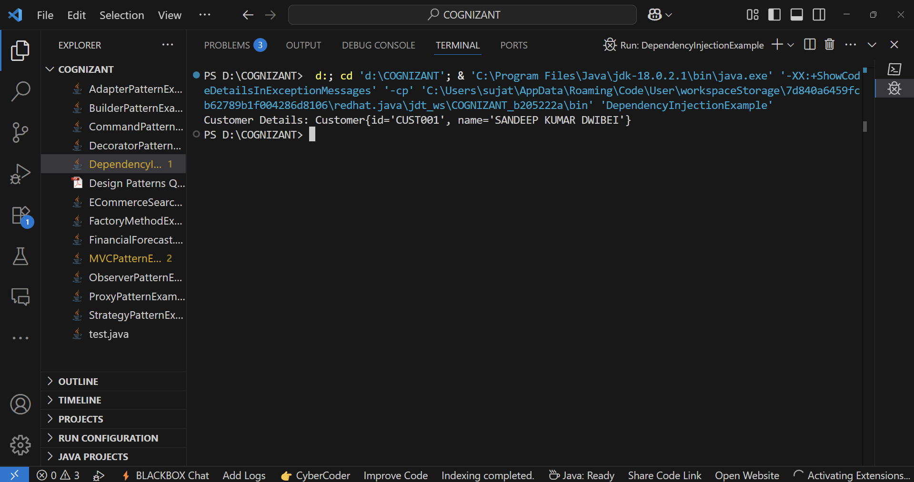**OUTPUT:-**